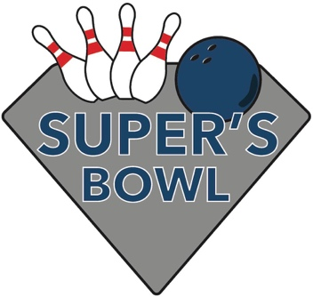
Donate an Auction Item!

Saturday, May 16, 2026
TEN PIN ALLEY • 6285 Nesbitt Road, Fitchburg

Donated auction items will be used for raffles at the event. All proceeds will go to Friends of Diabetes Research to benefit Breakthrough T1D (formerly JDRF).
You may mail the items/gift certificates, or someone can pick them up.

Thank you for supporting a cure for type 1 diabetes.

Please describe your donation & estimated value

Company & Donor Name

Mailing Address

Email Address

Phone Number Date ready for pick up

To learn more visit FriendsofDiabetesResearch.org
Questions? Email us at FriendsofDiabetesResearch@gmail.com

Return this form to:
Friends of Diabetes Research
C/O Amy Raven-Sorge CPA
2501 W. Beltline Hwy, Suite 101
Madison, WI 53713

